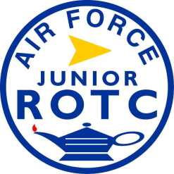

STAFF APPLICATION

General Information
- Name:
- Grade Level: Freshman / Sophomore / Junior / Senior
- AS-Level (circle one): I / II / III / IV
- Permanent Rank:
- Flight:
- School:

Leadership Information
- Flight Leadership History: Flight Commander / Flight Sergeant / None
- Leadership Training: BCO / SLS / CCSS / None / Other, specify:
- Previous Staff Positions:
1.
2.
3.
-Current Clubs/Teams (not JROTC):

Job Information
- Do you have transportation to Ferguson Education Center after school? Yes / No

- Can you provide other cadets from your school transportation to Ferguson Education Center?
Yes / No

- Desired Staff Positions (Specify!):

1.

2.

3.

Signature: Date:

